# Medicare D Compass Software Release – August 21, 2025

Always Log Out Before a Software Release

Display the transition Fill messaging for Med D

Update to NIS for CD&A

RTB Observation - ITPR073245 - Support Tasks - Issue creating Callback from Med D No Member Found Tasks

RTB Observation - ITPR073245 - One-time payment button enabled/synced API

RTB Optimization - ITPR073247 - M3P - One Time and Automatic payment data not mapped correctly

RTB Enhancement - ITPR073247 - NEJE Premium Billing task Update - Gap

Intake- ITPR076854 - Fazal Member Search

Intake- ITPR076854 - Display Fazal Member Search Results

Intake -ITPR076854 - Create Med D Enrollment - Support Task Actions Picklist Changes

Intake- ITPR076854 - Opt Hold/Group Attestation Support Task - Outside Interaction case

Intake- ITPR076854 -Fazal Search Results -Prepopulate Task Fields - Outside Interaction case

Intake- ITPR076854 - Enhance Med D Address Change and OOA support task

Intake - ITPR074103 - Med D CD&A Initiation points

Intake - ITPR074103 - Initiate Coverage Determination from Claim

Intake - ITPR074103 - Med D CD&A flow enhancement

Intake - ITPR074103 - Display Create Coverage Determination Request button - Verify Provider Screen

Intake - ITPR074103 - Display CD&A Request Screen

Intake - ITPR074103 - Submit CD&A Request to MHK and Service Request

Intake - ITPR074103 - Generate email notifications of Med D CD&A submissions - Reporting

Intake - ITPR074103 - Submission of CD&A Task (API fails)

Intake - ITPR0717725 IRA Medicare Maximum Fair Price (MFP) Drug Negotiation Program

Intake – ITPR077752 – Warning When Attempting to Expedite Grievances to MHK Nitro

**Description:** Outlines the new features for the August 2025 Software Release for Medicare D effective 08/21/2025. Please give us your feedback about this Announcement by completing [this brief survey](https://forms.office.com/Pages/ResponsePage.aspx?id=uGG7-v46dU65NKR_eCuM1wxlZbzQAA5CrF9MJTTfTF9URVMxVllLNEdWOVZXVUVISzgzOTRHTDZFVi4u)!

|  |
| --- |
| Always Log Out Before a Software Release |

**Each time** a software release is completed you must clear your cache. Please ensure that you Log Out of the Compass system the day before the Software Release.

|  |  |
| --- | --- |
| **Step** | **Action** |
| **1** | Click on your profile picture next to the Bell icon on the top right of the Compass application and select **Log Out**.   * Do Not click the X to close the browser as this will not log you out of the Compass system. * If you forget to log out, refer to [Clearing Your Cache (008655)](https://thesource.cvshealth.com/nuxeo/thesource/#!/view?docid=cd7acfcb-ad36-4da3-b973-faf08afb7dea). |

Top of the Document

|  |
| --- |
| Display the transition Fill messaging for Med D |

Refer to the table below:

|  |  |
| --- | --- |
| **User Story #​** | US705652 |
| **Line of Business** | Med D |
| **Impacted Feature/ Screen​** | Test claims results screen, refill, new rx, early refill |
| **Why/What is driving the change** | User feedback |
| **Current State​** | Agents have no visibility if a transition fill was used when providing pricing to a member. The agent is unable to educate the member that the drug paid under a transition fill and that a PA would be required going forward. |
| **Future State​** | On the test claim screen when selecting view messages, system will show the option to View messages. If a transition fill was used, that information will be available  For refill, the option to view messages will be available on an accepted claim  For new Rx, system will have a hyperlink on the cost field for each rx to enable the user to view financial details. They will also have the option to view additional messages on an accepted claim. |

Top of the Document

|  |
| --- |
| Update to NIS for CD&A |

Refer to the table below:

|  |  |
| --- | --- |
| **User Story #​** | US718391 |
| **Line of Business** | Med D |
| **Impacted Feature/ Screen​** | CD&A |
| **Why/What is driving the change** | Adopting the new Not available at mail indicator for alternatives |
| **Current State​** | Mail availability indicator is not available when viewing alternatives on CD&A |
| **Future State​** | Mail availability indicator will be available when viewing alternatives on CD&A so agent can provide the member with appropriate options |

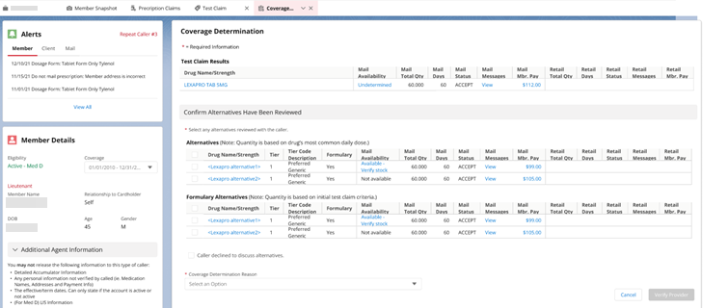

Top of the Document

|  |
| --- |
| RTB Observation - ITPR073245 - Support Tasks - Issue creating Callback from Med D No Member Found Tasks |

Refer to the table below:

|  |  |
| --- | --- |
| **User Story #​** | US689272 |
| **Line of Business** | Medicare D |
| **Impacted Feature/ Screen​** | Support Task – Med D No Member Found |
| **Why/What is driving the change** | Received feedback |
| **Current State​** | When submitting a call back task for certain Med D No Member Found Support Tasks, the call back task is assigning the task to the submitter and not the applicable queue  2a. Enrollment - Cancellation of Enrollment  2b. Enrollment - Cancellation of Enrollment - OEV  2c. Enrollment - Enrollment/Eligibility Discrepancy  2d. Enrollment - Enrollment Not Found  2e. Enrollment - Missing Pre-enrollment Information - RFI |
| **Future State​** | These callback tasks will assign to the applicable call back queue |

Top of the Document

|  |
| --- |
| RTB Observation - ITPR073245 - One-time payment button enabled/synced API |

Refer to the table below:

|  |  |
| --- | --- |
| **User Story #​** | US718370 |
| **Line of Business** | Med D |
| **Impacted Feature/ Screen​** | M3P summary tab |
| **Why/What is driving the change** | Screen is loading faster than the API (API takes longer than 3 seconds to load). |
| **Current State​** | The one-time payment button is showing disabled when the member isn’t enrolled in automatic payments |
| **Future State​** | The one-time payment button will be enabled when the member has a total balance greater than $0 and when the member isn’t enrolled in automatic payments |

Top of the Document

|  |
| --- |
| RTB Optimization - ITPR073247 - M3P - One Time and Automatic payment data not mapped correctly |

Refer to the table below:

|  |  |
| --- | --- |
| **User Story #​** | US706037 |
| **Line of Business** | Med D |
| **Impacted Feature/ Screen​** | M3P Instamed screen |
| **Why/What is driving the change** | The MBI-HCF not formatted correctly |
| **Current State​** | When enrolling a member into Autopay for M3P, Compass is passing the MBI-HCF to Instamed Member ID with the  member's name. This incorrect data file is also sent to WIPRO in the incorrect format. format, causing the Auto Pay sign up  files to pend. |
| **Future State​** | Compass will pass the member's MBI and the assigned HCF to the Instamed Member ID field. |

Top of the Document

|  |
| --- |
| RTB Enhancement - ITPR073247 - NEJE Premium Billing task Update - Gap |

Refer to the table below:

|  |  |
| --- | --- |
| **User Story #​** | US711095 |
| **Line of Business** | Med D |
| **Impacted Feature/ Screen​** | Support Task |
| **Why/What is driving the change** | Coordination of Benefits is missing from the ‘Reason for Dispute’ picklist for NEJE premium billing support task |
| **Current State​** | Coordination of Benefits is missing from the ‘Reason for Dispute’ picklist for NEJE premium billing support task |
| **Future State​** | The Coordination of Benefits will display to the picklist and will display for NEJE premium billing support task |

Top of the Document

|  |
| --- |
| Intake- ITPR076854 - Fazal Member Search |

Refer to the table below:

|  |  |
| --- | --- |
| **User Story #​** | US711914 |
| **Line of Business** | Med D |
| **Impacted Feature/ Screen​** | Search by Medicare D tab |
| **Why/What is driving the change** | To search FAZAL when the member isn’t  found in the Med D search |
| **Current State​** | User must pull up FAZAL to continue search for member |
| **Future State​** | Compass will automatically search for the member in question when no results are returned from the first search done on the Med D search tab |

Top of the Document

|  |
| --- |
| Intake- ITPR076854 - Display Fazal Member Search Results |

Refer to the table below:

|  |  |
| --- | --- |
| **User Story #​** | US712479 |
| **Line of Business** | Med D |
| **Impacted Feature/ Screen​** | Search by Med D tab |
| **Why/What is driving the change** | To have visibility of the search results that are returned  From the FAZAL search |
| **Current State​** | Search results only display in FAZAL application |
| **Future State​** | Search results will now be integrated within Compass |

Top of the Document

|  |
| --- |
| Intake -ITPR076854 - Create Med D Enrollment - Support Task Actions Picklist Changes |

Refer to the table below:

|  |  |
| --- | --- |
| **User Story #​** | US712868 |
| **Line of Business** | Med D |
| **Impacted Feature/ Screen​** | Search by Member, Search by Retail Rx,  Search By Mail Order/Internal ID and  Search by Medicare D |
| **Why/What is driving the change** | To only have the "Create Med D Enrollment Support Task" viewable in the Search by Medicare D tab. In addition, adding View Support Tasks - Med D (No Member Found) “to the Search by Medicare D tab as well |
| **Current State​** | Create Med D Enrollment exists on all search tabs (Search by Member, Search by Retail Rx, Search By Mail Order/Internal ID and Search by Medicare D) |
| **Future State​** | Create Med D Enrollment will only exist on the Search by Medicare D tab for onshore users. In addition, a new option will be placed called View Support Task Med D (No Member Found) for users to see all tasks submitted outside of an interaction case as well as a task description when users select No Member Found (Non-Med D) and try to switch the task type. |

Top of the Document

|  |
| --- |
| Intake- ITPR076854 - Opt Hold/Group Attestation Support Task - Outside Interaction case |

Refer to the table below:

|  |  |
| --- | --- |
| **User Story #​** | US711913 |
| **Line of Business** | Med D |
| **Impacted Feature/ Screen​** | Search by Medicare D tab |
| **Why/What is driving the change** | To allow users to create an opt hold/group attestation task outside or in an account |
| **Current State​** | Users can only create the task inside an interaction case |
| **Future State​** | To allow users to create the support task outside of an account and an interaction case |

Top of the Document

|  |
| --- |
| Intake- ITPR076854 -Fazal Search Results -Prepopulate Task Fields - Outside Interaction case |

Refer to the table below:

|  |  |
| --- | --- |
| **User Story #​** | US713603 |
| **Line of Business** | Med D |
| **Impacted Feature/ Screen​** | Support Task |
| **Why/What is driving the change** | To have the data from the search results pre-populated on the support task |
| **Current State​** | Users to have complete the required fields in the support task |
| **Future State​** | The data returned from the search results will carry over to the support task |

Top of the Document

|  |
| --- |
| Intake- ITPR076854 - Enhance Med D Address Change and OOA support task |

Refer to the table below:

|  |  |
| --- | --- |
| **User Story #​** | US713987 |
| **Line of Business** | Med D |
| **Impacted Feature/ Screen​** | Support Task |
| **Why/What is driving the change** | To enhance the OOA and Address Change support tasks so that it can be automatically determined if the member is considered ‘Out of area’ or ‘In area’ |
| **Current State​** | This doesn’t exist currently in either task |
| **Future State​** | An OOA check read only field will display and when the address is added in the task, then compass will advise if the address is considered ‘Out of Area’ or ‘In area’ |

Top of the Document

|  |
| --- |
| Intake - ITPR074103 - Med D CD&A Initiation points |

Refer to the table below:

|  |  |
| --- | --- |
| **User Story #​** | US704233 |
| **Line of Business** | Med D |
| **Impacted Feature/ Screen​** | Claims tab and Rx Details (Claims Details, Transmission Details, and Financial Details) sub-tabs |
| **Why/What is driving the change** | To allow users to initiate a coverage determination from a rejected claim based on specified reject codes |
| **Current State​** | Users can only initiate a coverage determination from ‘Test Claims’ |
| **Future State​** | User will be able to initiate a coverage determination from a rejected claim on file based on specified reject codes either from the row level action from the Claims tab or the Rx Details (Claims Details, Transmission Details, and Financial Details) sub-tabs |

Top of the Document

|  |
| --- |
| Intake - ITPR074103 - Initiate Coverage Determination from Claim |

Refer to the table below:

|  |  |
| --- | --- |
| **User Story #​** | US706078 |
| **Line of Business** | Med D |
| **Impacted Feature/ Screen​** | Claims tab and Rx Details (Claims Details, Transmission Details, and Financial Details) sub-tabs |
| **Why/What is driving the change** | To have the ability to launch the coverage determination flow from the rejected claim |
| **Current State​** | User is unable to initiate a coverage determination from a rejected claim on file |
| **Future State​** | User will be able to initiate a coverage determination from a rejected claim on file and launch the coverage determination flow |

Top of the Document

|  |
| --- |
| Intake - ITPR074103 - Med D CD&A flow enhancement |

Refer to the table below:

|  |  |
| --- | --- |
| **User Story #​** | US702970 |
| **Line of Business** | Med D |
| **Impacted Feature/ Screen​** | Coverage Determination tab |
| **Why/What is driving the change** | To enhance the coverage determination flow and allow users to select Prior Authorization, Quantity Limit Exception, or Step Therapy Exception as a Coverage Determination Reason in the guided flow |
| **Current State​** | Prior Authorization, Quantity Limit Exception, and Step Therapy Exception can only be selected when creating the Med D CD&A support task. |
| **Future State​** | Users will now have the option to also select Prior Authorization, Quantity Limit Exception, or Step Therapy Exception as a Coverage Determination Reason along with the other existing values. In addition, the coverage determination guided flow will also have a ‘Requestor’ field for users to capture the caller's name if changed and based off the selected coverage determination reason selected, the guided flow will change |

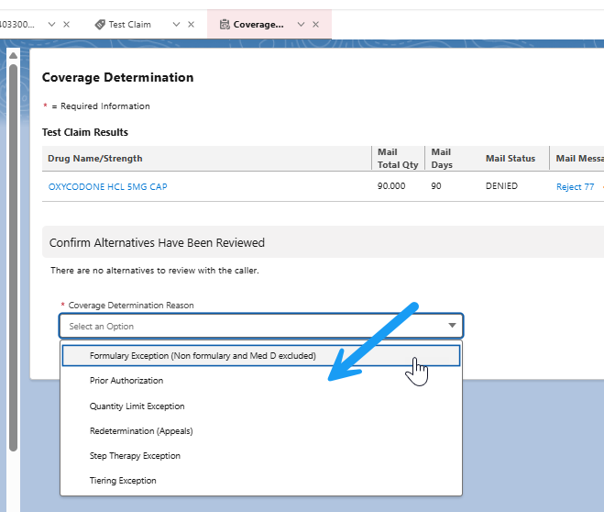

Top of the Document

|  |
| --- |
| Intake - ITPR074103 - Display Create Coverage Determination Request button - Verify Provider Screen |

Refer to the table below:

|  |  |
| --- | --- |
| **User Story #​** | US702825 |
| **Line of Business** | Med D |
| **Impacted Feature/ Screen​** | Coverage Determination tab (Verify Provider screen) |
| **Why/What is driving the change** | To remove ‘Create CD&A Support Task’ button and lead users to the next screen when the button is enabled |
| **Current State​** | A button labeled Create CD&A Support Task displays |
| **Future State​** | Users will now see a new button labeled Create Coverage Determination Request instead |

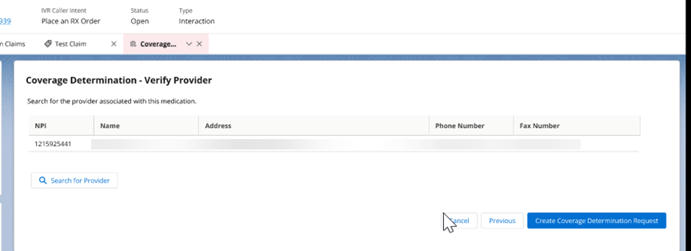

Top of the Document

|  |
| --- |
| Intake - ITPR074103 - Display CD&A Request Screen |

Refer to the table below:

|  |  |
| --- | --- |
| **User Story #​** | US690003 |
| **Line of Business** | Med D |
| **Impacted Feature/ Screen​** | Coverage Determination tab (Coverage Determination Request screen |
| **Why/What is driving the change** | To allow users to capture pertinent info prior to submitting the coverage determination request |
| **Current State​** | This screen doesn’t exist today |
| **Future State​** | A new screen will display after the Coverage Determination Verify Provider screen that will take the user to the Coverage Determination Request screen for the user to submit the coverage determination request |

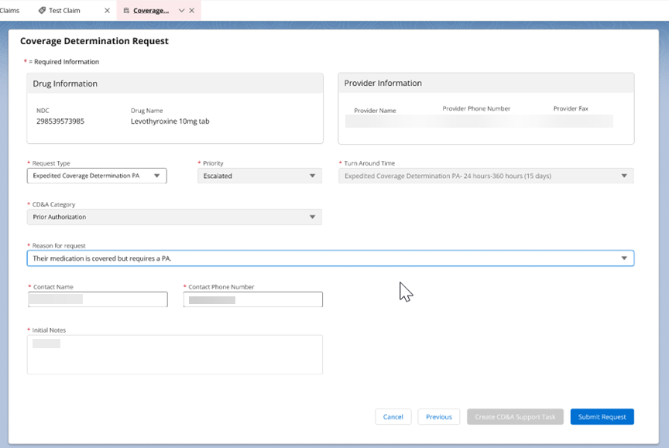

Top of the Document

|  |
| --- |
| Intake - ITPR074103 - Submit CD&A Request to MHK and Service Request |

Refer to the table below:

|  |  |
| --- | --- |
| **User Story #​** | US690009 |
| **Line of Business** | Med D |
| **Impacted Feature/ Screen​** | Coverage Determination tab (Coverage Determination Request screen) |
| **Why/What is driving the change** | To have the coverage determination request sent to Medhok directly |
| **Current State​** | This doesn’t exist today. Users must submit a support task that stays in a queue until handled by the appropriate team |
| **Future State​** | Users will now be able to submit a request from the Coverage Determination Request screen that will be sent to Medhok directly |

Top of the Document

|  |
| --- |
| Intake - ITPR074103 - Generate email notifications of Med D CD&A submissions - Reporting |

Refer to the table below:

|  |  |
| --- | --- |
| **User Story #​** | US703567 |
| **Line of Business** | Med D |
| **Impacted Feature/ Screen​** | Reporting |
| **Why/What is driving the change** | To generate only failed submission requests to the appropriate teams so that they can monitored and handled accordingly |
| **Current State​** | This report doesn’t exist today |
| **Future State​** | A report will be generated for all failed submission requests. In addition, successful submission will also be captured but will viewable when pulled from Compass |

Top of the Document

|  |
| --- |
| Intake - ITPR074103 - Submission of CD&A Task (API fails) |

Refer to the table below:

|  |  |
| --- | --- |
| **User Story #​** | US703614 |
| **Line of Business** | Med D |
| **Impacted Feature/ Screen​** | Support Task |
| **Why/What is driving the change** | To only allow users to submit the Med D CD&A support task if the submission request fails |
| **Current State​** | Users can submit the Med D CD&A support task anywhere in Compass |
| **Future State​** | Users now will only be able to submit the Med D CD&A support task if the submission request fails on the Coverage Determination Request screen. Users will not be able to submit this support task from Create Support Task button |

Top of the Document

|  |
| --- |
| Intake - ITPR0717725 IRA Medicare Maximum Fair Price (MFP) Drug Negotiation Program |

Refer to the table below:

|  |  |
| --- | --- |
| **User Story #​** | US686784, US686785, US686786, and US686787 |
| **Line of Business** | Med D |
| **Impacted Feature/ Screen​** | Claims Details/Medicare Part D tab  Claims Financial Details Screen  Test Claim Financial Details  Claims Transmission Details |
| **Why/What is driving the change** | Due to the Inflation Reduction Act, CMS has negotiated drug pricing on selected high-priced drugs. This new pricing program is called the Medicare Maximum Fair Price (MFP). |
| **Current State​** | This doesn’t exist today |
| **Future State​** | For 2026, CMS negotiated pricing for 10 brand name drugs (which applies to 141 NDC’s). The MFP pricing program is effective for applicable Medicare Part D drugs starting on January 1, 2026. Plans must include these NDCs on their formularies and must be setup to price claims for these NDCs using the MFP pricing.  (FYI – CMS will add an additional 15 drugs to this list in 2027, and then 20 drugs every year after that).  For claims priced after January 1, 2026, users will be able to see when the MFP pricing can be applied based on the drug NDC and the Wholesale Acquisition Cost (WAC) pricing. The user will also see the savings between the MFP and WAC that will be applied to the claim as the MFP Cost Difference.  3 options will be available for the “Maximum Fair Price (MFP) Applied” field:  1. MFP Applied and Winning = NDC is applicable for MFP, and the MFP price is lower than the WAC price.  2. MFP Exists but not Winning = NDC is applicable for MFP, but the MFP price is higher than the WAC price.  3. Blank = NDC is not eligible for MFP.  MFP pricing information will be shown in 2 new fields:   1. MFP Unit Cost 2. MFP Cost Difference |

**Claims Details/Medicare Part D tab**

Maximum Fair Price (MFP) Applied *(3 options available)*: MFP Applied and Winning, MFP Exists but not Winning, or Blank

**Claims Med D Financials**

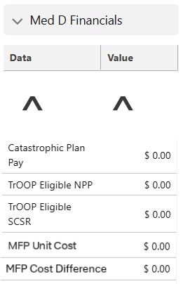

**Test Claim Financial Details**

Display MFP Applied *(1 of 3 options will be displayed)*: MFP Applied and Winning, MFP Exists but not Winning, or Blank.

Display MFP Unit Cost and MFP Cost Difference

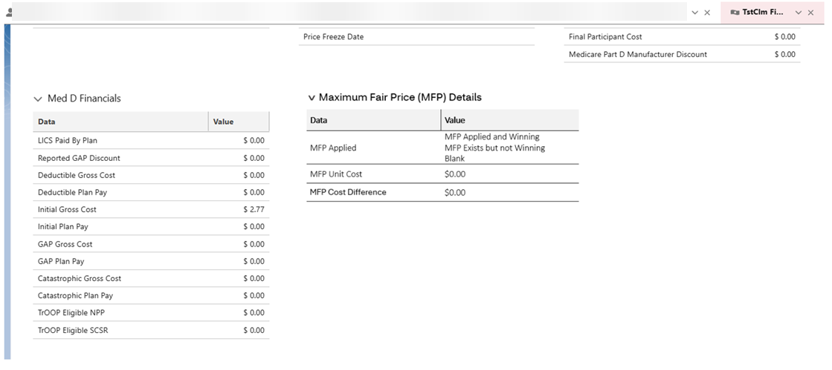

**Claims Transmission Details**

* **Transaction IN**

MFP Applied *(1 of 3 options will be displayed)*: MFP Applied and Winning, MFP Exists but not Winning, or Blank

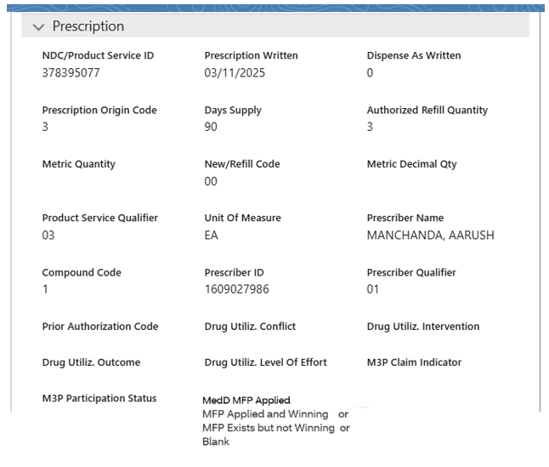

* **Transaction OUT**

Display MFP Unit Cost and MFP Cost Difference

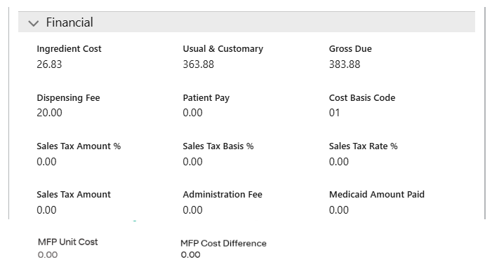

Top of the Document

|  |
| --- |
| Intake – ITPR077752 – Warning When Attempting to Expedite Grievances to MHK Nitro |

Refer to the table below:

|  |  |
| --- | --- |
| **User Story #​** | US715524 |
| **Line of Business** | MHK Nitro Users |
| **Impacted Feature/ Screen​** | Grievance |
| **Why/What is driving the change** | Ops Request |
| **Current State​** | Currently, for grievances being routed to the MHK Nitro backend, the system has a selection to indicate whether the grievance is standard or expedited priority that defaults to standard. If the rep changes this to expedited, there is no indicator of when this should be used. |
| **Future State​** | If the grievance priority is changed to expedited, there will be a message displayed to the rep indicating when this priority should be used, and warning them to change it back to standard if the grievance doesn’t meet one of those criteria. (No screenshot/wireframe available at this time). |

Top of the Document

|  |
| --- |
| Related Documents |

[Compass Software Release – Shared – August 21, 2025 (076276)](https://thesource.cvshealth.com/nuxeo/thesource/" \l "!/view?docid=a6c3a564-b2a4-404d-9f83-7bcdf4e8600e)

Top of the Document

Not To Be Reproduced Or Disclosed to Others Without Prior Written Approval

**ELECTRONIC DATA = OFFICIAL VERSION / PAPER COPY = INFORMATIONAL ONLY**